**Figure 7:** Effect of Heat Stress on the Tuber Weight (g) of Five Potato Varieties. Vertical bars indicate the standard error of the mean against each variable. The different letter indicates significant difference at a 5% level of significance among data.

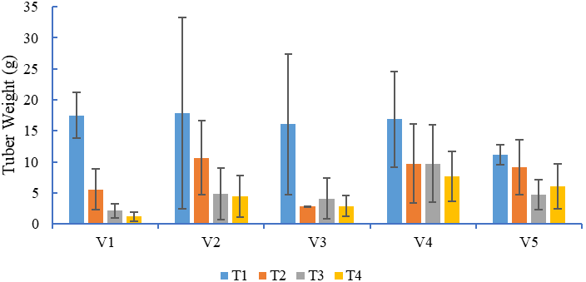

a

c-e

de

e

a

a-d

c-e

c-e

ab

c-e

c-e

c-e

a

a-e

a-e

b-e

a-c

a-e

c-e

c-e